
… .. PROJECT OF SOLAR ENERGY
A MAJOR PROJECT REPORT
Submitted in the Partial fulfillment for the award of Bachelor of Technology in Mechanical Engineering
Submitted to
RAJIV GANDHI PROUDYOGIKI VISHWAVIDYALAY
Bhopal (MP)



Submitted by
Umashankar Longare(0124ME171022)
Vikash Mankar(0124ME171023)
Dinesh (0124ME171008)

Under the Guidance of
Suresh badholiya


DEPARTMENT OF MECHANICAL ENGINEERING
BHOPAL INSTITUTE OF TECHNOLOGY AND SCIENCE
BHOPAL (MP)
MAY 2021

BHOPAL INSTITUTE OF TECHNOLOGY & SCIENCE

BHOPAL (M.P.)


Batch - 2017-2021



DEPARTMENT OF MECHANICAL ENGINEERING

CERTIFICATE

This is to certify that Name of students Vikash Mankar of 4th year in Mechanical Engineering has done “ PROJECT OF SOLAR ENERGY  as his Major project for partial fulfillment of bachelor of Engineering Degree from RGPV Bhopal (MP).

Prof. Suresh badholiya
Project guide

Prof. Rohit Choudhary Dr. Ashutosh Sharma
HOD (ME) PRINCIPAL



BHOPAL INSTITUTE OF TECHNOLOGY & SCIENCE
BHOPAL (M.P.)



Batch - 2017-2021

DEPARTMENT OF MECHANICAL ENGINEERING

CERTIFICATE OF APPROVAL

This is to certify that the Major Project work entitled  PROJECT OF SOLAR ENERGY  being submitted by Umashankar Longare , Vikash Mankar, Dinesh Enrollment No. 0124ME171022, 0124ME171023, 0124ME171008 has been examined by us and is here by approved for the award of degree of Bachelor of Technology in Mechanical Engineering for which it has been submitted. It is understood that by this approval the undersigned do not necessarily endorse or approve any statement made, opinion expressed or conclusion drawn there in but approve the dissertation only for the purpose for which it has been submitted.

(Internal Examiner) (External Examiner)

BHOPAL INSTITUTE OF TECHNOLOGY & SCIENCE, BHOPAL (M.P.)



Batch - 2017-2021

DEPARTMENT OF MECHANICAL ENGINEERING

DECLARATION

I/we hereby declare the work, which is being presented in the major project entitled " MAJOR PROJECT OF SOLAR ENERGY " in partial fulfillment of the requirements for the award of the degree of BACHELOR OF TECHNOLOGY’ in  MECHANICAL ENGINEERING has been carried out at, Bhopal Institute of Technology & Science (BITS), Bhopal is an authentic record of my/our own work carried out under the guidance of my/our project guide Prof. Suresh badholiya

The matter embodied in this project work has not been submitted by me for the award of any other degree.

Umashankar Longare Vikash Mankar
Roll No. 0124ME171022 Roll No.0124ME171023


Dinesh Prof. Suresh badholiya
Roll No. 0124ME171008 (Project Guide)

BHOPAL INSTITUTE OF TECHNOLOGY & SCIENCE, BHOPAL (M.P.)



DEPARTMENT OF MECHANICAL ENGINEERING

ACKNOWLEDGEMENT

It is immense pleasure to express my/our deepest sense of gratitude and sincere thanks to my/our highly respected and esteemed, Prof. Suresh badholiya , Department of Mechanical Engineering for his/her unflinching support, guidance and pearls of wisdom to enable me to complete this thesis.
I/We would like to give warm expression of thanks to Dr. Ashutosh Sharma,

CONTENTS

- OBJECTIVE
- DEFINITION OF ENERGY
- MAIN SOURCES OF RENEWABLE ENERGY
- ADVANTAGES AND DISADVANTAGES OF RENEWABLE ENERGY
- PHOTO VOLTAIC (PV) CELLS
- SOLAR HOME SYSTEM (SHS)
- SOLAR HOME SYSTEM POTENTIAL IN BANGLADESH
- SITE SELECTION
- HOUSEHOLD SURVEY
- DATA COLLECTION QUESTIONNAIRE FOR SHS
- SURVEY STOCKHOLDER
- DATA ANALYSIS AND RESULT
- FUTURE SCOPE
- CONCLUTION

OBJECTIVE

• Installation of all type of solar technology i.e. solar power plant (On -Grid and Off-Grid), solar water pumping system, solar street lighting system and solar home lighting system.
• Enhancing the technology by continuous research and development.
• To assess the role of SHS on socio-economic development in Bangladesh.
• To compensate for the growing energy demand by using Renewable energy source like solar.
• Low power consumption, Reliability our product. • Low maintenance.
DEFINITION OF ENERGY

Energy: Energy is the ability to do work. The law of conservation of energy states that energy can be converted in form, but not created or destroyed. Two types of energy given blow
1. Renewable Energy
2. Non Renewable Energy

1. Renewable Energy: Renewable energy is energy that is collected from renewable resources, which are naturally replenished on a human timescale, such as sunlight, wind, rain, tides, waves, and geothermal heat.

2. Non Renewable Energy : A non-renewable resource (also called a finite resource) is a resource that does not renew itself at a sufficient rate for sustainable economic extraction in meaningful human time-frames.

ADVANTAGES AND DISADVANTAGES OF RENEWABLE ENERGY

Easily Regenerated | Weather Dependency
Boost Economic Growth High Installation Cost
Easily Available | Noise caused by Wind Energy
Support Environment | Fluctuation problem (Solar)
Low Maintenance Cost | Intermittency Issue (Wind)

MAIN SOURCES OF RENEWABLE ENERGY

• Wind Energy. • Biomass.
• Geothermal Energy. • Hydropower.
• Solar Energy (Photo voltaic (PV) Cells).

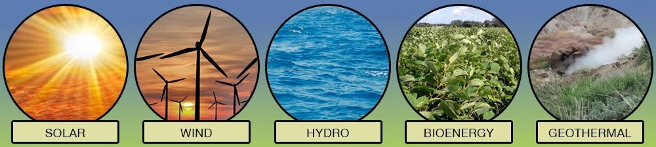

ADVANTAGES AND DISADVANTAGES OF RENEWABLE ENERGY
Easily Regenerated | Weather Dependency
Boost Economic Growth High Installation Cost
Easily Available | Noise caused by Wind Energy
Support Environment | Fluctuation problem (Solar)
Low Maintenance Cost | Intermittency Issue (Wind)

Photo voltaic (PV) Cells

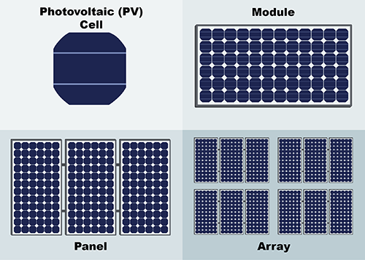
A photovoltaic system also solar power system is a power system designed to purvey usable solar power by means of photovoltaic. It consists of an arrangement of different components, with solar panels to absorb and convert sunlight into electricity, a solar inverter to switch the electric current from DC to AC, as well as mounting, cabling, and other electrical accessories to set up a working method. The long term average sunshine data indicates that the period of bright sunshine hours in the coastal regions of Bangladesh varies from 3 to 11 hours daily. PV cells generate electricity from sunlight. Materials used in computer chips are like to materials used in Photo voltaic cells.

Solar Home System (SHS)

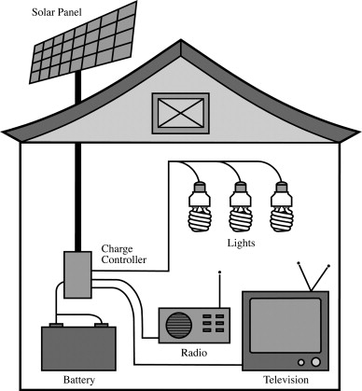
The direct conversion of sunlight into electricity is called photovoltaic solar energy conversion. An essential component of Photo Voltaic (PV) system is the solar cell, in which the photovoltaic effect takes place. When light falls on the semiconductors of the cell, it produces a small electric current. Photovoltaic modules, or panels, consist of a number of cells connected together to provide voltages and currents high enough for practical use. More common in rural electrification programs is the use of solar PV as stand-alone systems in households, social institutions, or places of productive or business activities. Generally, the system is referred to as ‘Solar Home System’ (SHS). The SHS providing load is low ,but can be sufficient for powering of lights, radios, television sets, and to refrigerate medicines at rural clinics.

Household survey

To reveal quantitative as well as qualitative information from users of SHS, empirical household level data are collected through a household survey conducted in one village. Overall, 27 interviews in rural households have been conducted by designed questionnaire. The questionnaire is designed based on selected variables of the study.

Data Collection Questionnaire for SHS Technical Information

Date of installation/operation |  | 20/02/2014
Company name |  | Rural services foundation
Plant Capacity |  | 20W
Panel life |  | 15 years
Battery | Origin | Bangladesh (Rahimafroz)
 | Capacity (Ah) | 30
 | Warranty (Years) | 5 years
 | Battery life | 10-15 years
Charge controller | Origin
 | Capacity
 | Warranty (Years)
 | C. controller life
Appliances | Load | Watt | Quantity | Total use hours (estimated)
 | Light | 5 | 3 | 5

Economic Information

Cost of SHS (Tk.) | 12200
Down payment (Tk.) | 1220
Interest rate (%) | 7.54%
Loan repayment/installment (Tk.) | 11805
Payback period (years) | 3 years
Total number of installment | 36
Maintenance cost/year | 510
Battery Price (Tk.) | 7000
Charge controller price (Tk.)

Social Assessment

Name of SHS owner | Md. Nadim Hossain
Occupation | Farmer
Number of family members | 6
Monthly income before using SHS (Tk.) | 18000
Monthly income after using SHS (Tk.) | 18000
Change of number of students | Before using SHS | 3
 | After using SHS | 3
Study hour at night | Before using SHS | 2
 | After using SHS | 3
How did they find the performance of SHS? | Bad  Satisfactory  Good  Very good
Are you satisfied with your system provider service? | Bad  Satisfactor  Good  Very good
What types of problems do you faced with your SHS? | Not yet.
Is SHS electricity is enough for your family? | Not enough
Do you have any comment about installment? | No comments
What amount (Liter) kerosene did you used? | Before using SHS | 6
 | After using SHS | -
Do you like to use TV or Fan or others/to increase your SHS capacity? | Yes

SURVEY STOCKHOLDER

  - Various Companies

  - Purchasing mode

  - Expenditure before SHS

  - Expenditure after SHS

  - Economic State before SHS

  - Economic State after SHS

  - Educational scenario before SHS

  - Educational scenario after SHS

Various companies in survey area

People of the Naria upazilla in Shariatpur use only two Companies SHS. Ø Grameen Shakti.

Ø Rural services foundation.

But Grameen Shakti is more popular then Rural services foundation

Company.
20
18
16
14
12
10
8
6
4
2
0

Purchasing mode of SHS

Mode of purchasing  SHS | Percentage (%) | Month of installment
Pay whole amount of  money | 29.62
Installment | 70.38 | 12-36

Panel  capacity (W) | Cost of SHS  (TK) | Down  payment  (TK) | Installment  (TK) | Total no of  Installment | Interest rate  (%)
40 | 20000 | 20000
20 | 12200 | 1220 | 328 | 36 | 7.54
20 | 12000 | 2500 | 855 | 12 | 7.95
21 | 12000 | 5000 | 350 | 24 | 19.86
20 | 7500 | 7500

Interest Rate (%)

If,
Cost of SHS (TK) = 12200 TK Down payment (TK) =1220 TK So,
Total Loan repayment (TK) = Cost of SHS (TK) - Down payment (TK) = (12200 – 1220) TK
= 10980 TK If,
Total number of installment = 36 So,
Monthly installment = Total Loan repayment - Total number of installment = 10980/36
= 305 TK
But analyze our survey data we know their monthly installment 328 TK So,
Given excess money per month = 328 – 305 = 23 TK
Therefore,
Interest rate = (23*100/305) = 7.54 %

Expenditure Before SHS

Name | Family  member | Fuel type | Fuel  consumption  (L) | Cost of  fuel per  month  (TK) | Per head  per month  fuel cost  (TK)
Ayub-Ali-Khan | 4 | Kerosene | 6 | 264 | 66
Md. Nadim Hossain | 6 |  | 6 | 264 | 44
Hossain Soial | 4 |  | 5 | 220 | 55
Abu Kalam Soni | 4 |  | 5 | 220 | 55
Kashem Choddar | 5 |  | 5 | 220 | 44
Milon Daw | 4 |  | 5 | 220 | 55

Before installation of SHS, kerosene was the most prevalent source of household lighting.
Per liter kerosene price about 44 tk.

Expenditure After SHS

Owner name | No of  family  member | Panel  capacity  (W) | Generated  electricity  per month  (Kwh) | Per unit  cost  (TK/K  Wh) | Total  cost  Per  month  (TK) | Per head  cost per  month  (TK)
Ayub-Ali-Khan | 4 | 40 | 3.46 | 48.63 | 168.62 | 42.10
Md. Nadim  Hossain | 6 | 20 | 2.28 | 46.76 | 106.67 | 17.77
Hossain Soial | 4 | 20 | 1.06 | 94.68 | 100.79 | 25.19
Abu Kalam Soni | 4 | 21 | 1.94 | 58.80 | 114.46 | 28.61
Kashem Choddar | 5 | 20 | 1.82 | 46.12 | 84.16 | 16.63
Milon Daw | 4 | 20 | 1.52 | 69.11 | 105.10 | 26.27

Economics state of the selected household

Occupation of household head and spouse

Household head | Percent | Spouse | Percent
Farmer | 48.14 | Housewife | 100
Fisherman | 3.70
Abroad | 11.11
Boat Driver | 3.70
Business | 7.40
Driver | 3.70
Job | 18.51
Farmer And  Fisherman | 3.70

Household total income before SHS
Household total income (BDT/month) | Percent
5000-10000 | 33.33
11000-15000 | 42.85
16000-20000 | 23.80
Above 20000 | 0

Household total income after SHS
Household total income (BDT/month) | Percent
5000-10000 | 4.76
11000-15000 | 47.61
16000-20000 | 28.17
Above 20000 | 19.04
Educational scenario

change no of students for SHS

Name | No of student before  SHS | No of student after SHS
Ayub-Ali-Khan | 1 | 1
Md. Nadim Hossain | 3 | 3
Hossain Soial | 0 | 1
Abu Kalam Soni | 1 | 1
Kashem Choddar | 1 | 2

Educational scenario

Change study hour at night for SHS

Name | Study hours before SHS  ( h) | Study hours after SHS  ( h)
Ayub-Ali-Khan | 2 | 4
Md. Nadim Hossain | 2 | 3
Hossain Soial | 0 | 2
Abu Kalam Soni | 1 | 3
Kashem Choddar | 2 | 4

Future Scope

A reliable, affordable and secure supply of energy is important for socio-economic development. As a country of acute power crisis Bangladesh is now looking forward to develop its renewable energy sources in addition to its traditional sources of fossil fuel. Solar energy is the most abundant renewable energy source of Bangladesh. Taking advantage of it we can enrich our regular life. In this paper we have tried to focus on the alternative uses of solar energy to ensure the energy security in near future. A solar based electric vehicle recharging station can reduce the fossil fuel consumption in transportation sector without using any power from grid and will keep our environment clean. A DC grid in off grid area based on solar PV can solve our irrigation problem as well as will ensure a better life for the rural people. Solar cooking can be a viable option for cooking both in rural and city area for reducing the natural gas consumption and burning of wood stock. So by ensuring these l prospects we can solve our energy and gas crisis; and ensure a green environment for the future generations.

Limitations of the study

During field work some limitations are encountered. These are:-

- The village is located in a remote area, so the travel arrangements there are very bad.
- Most of the people there were illiterate; they could not answer our many questions correctly.
- At first they were feeling helpless to talk to us. Because they have not been surveyed before.

CONCLUSION

Providing electricity for meeting lighting needs of households and rural markets can bring several positive impacts including improvement of quality of life and increasing in income and employment opportunities. So, rural electrification through solar energy is a model to the users is that they are free from the responsibility of maintaining the system. The risk of the whole system has been avoided with the involvement of local community in management. Demonstration of solar energy system has been successful to create interest among the rural people and demand from other location also observed.

Thank You All

